Unveiling the Power of Chemical Earthing Electrodes: A Comprehensive Guide
Introduction:
In the realm of electrical safety, the significance of grounding cannot be overstated. Among the various grounding solutions available, Chemical Earthing Electrodes have emerged as a game-changer. This comprehensive guide delves into the intricacies of Chemical Earthing Electrodes, shedding light on their importance, benefits, and the role of leading manufacturers like Genius Protection System in ensuring electrical safety.
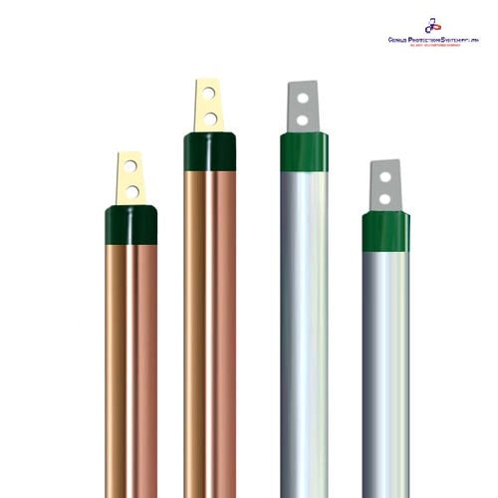
Understanding Chemical Earthing Electrodes:
Chemical Earthing Electrodes are advanced grounding solutions designed to enhance the efficiency and safety of electrical systems. Unlike traditional methods, these electrodes leverage a chemical compound to create a low-resistance pathway for fault currents, ensuring rapid dissipation into the ground. The primary purpose is to protect both equipment and individuals from the harmful effects of electrical faults.
The Benefits of Chemical Earthing Electrodes:
Enhanced Safety: Chemical Earthing Electrodes provide a reliable and low-resistance path for fault currents, minimizing the risk of electrical shocks and ensuring the safety of personnel.
Improved Equipment Lifespan: By dissipating fault currents efficiently, these electrodes prevent damage to electrical equipment, extending their lifespan and reducing maintenance costs.
Stability in Electrical Systems: Chemical Earthing Electrodes help maintain a stable reference point for voltage, reducing the risk of fluctuations that can adversely affect electronic devices and machinery.
Choosing the Right Chemical Earthing Electrode Manufacturer:
Selecting a reliable Chemical Earthing Electrode Manufacturer is crucial for ensuring the effectiveness of the grounding system. When seeking a trustworthy supplier, consider factors such as:
Experience and Expertise: Opt for manufacturers with extensive experience in the field. Companies like Genius Protection System have a proven track record, showcasing their expertise in producing high-quality Chemical Earthing Electrodes.
Compliance with Standards: Ensure that the manufacturer adheres to relevant industry standards and certifications. This ensures that the products meet the necessary safety and performance criteria.
Customization Options: A reputable manufacturer should offer a range of Chemical Earthing Electrodes to suit various applications. The ability to customize solutions based on specific requirements enhances the overall effectiveness of the grounding system.
Customer Reviews and Testimonials: Researching customer reviews and testimonials provides insights into the manufacturer's reputation and the performance of their products. Positive feedback from satisfied customers is a strong indicator of reliability.
Installation and Maintenance:
Proper installation and regular maintenance are critical to the effectiveness of Chemical Earthing Electrodes. During installation, ensure that the electrodes are placed at the correct depth and surrounded by a conductive mixture of soil and a specially formulated backfill compound.
Regular maintenance involves inspecting the electrodes for corrosion and ensuring that the surrounding soil remains conductive. Any signs of wear or degradation should be addressed promptly to maintain the integrity of the grounding system.
Environmental Impact:
Chemical Earthing Electrodes are designed with environmental sustainability in mind. The reduction of maintenance requirements and the use of eco-friendly materials contribute to a lower overall environmental impact compared to traditional grounding methods.
Conclusion:
In the dynamic landscape of electrical safety, Chemical Earthing Electrodes stand out as a reliable and efficient solution. As businesses and industries strive for enhanced safety measures, choosing the right grounding system becomes paramount. Genius Protection System, a leading Chemical Earthing Electrode Manufacturer, exemplifies the commitment to quality and safety in electrical systems. By integrating their expertise into your grounding solutions, you not only ensure compliance with industry standards but also contribute to a safer and more reliable electrical environment. Embrace the power of Chemical Earthing Electrodes and make Genius Protection System your partner in electrical safety.

Source URL: - https://www.apsense.com/article/unveiling-the-power-of-chemical-earthing-electrodes-a-comprehensive-guide.html

Address:
Corp Off: DCT - 601, DLF City Court, Sikanderpur, Gurgaon (H.R.)-122002
Factory: 47/13, Ganpati Dham Ind, Area Bahadurgarh (H.R)-124507
Email: - info@gpsindia.co.in
Call Us: - +91-9313916302
Facebook | Instagram

