Safeguarding Structures:
The Importance of Choosing the Right Lightning Protection System Manufacturer
As technology continues to advance, the need for reliable and effective lightning protection systems has become more critical than ever. In India, where thunderstorms are a common occurrence, the demand for robust Lightning Protection Systems (LPS) has seen a significant rise. This blog delves into the key aspects of lightning protection, the role of manufacturers, and the importance of implementing lightning protection systems in India.
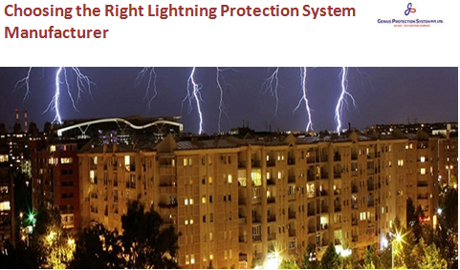
Understanding Lightning Protection Systems
What is a Lightning Protection System?
A Lightning Protection System is a sophisticated network of components designed to safeguard structures and occupants from the destructive forces of lightning. It typically includes lightning rods, conductors, grounding systems, and surge protection devices.
How Do Lightning Protection Systems Work?
Lightning protection systems operate on the principle of providing a low-resistance path for lightning to follow, directing the electrical discharge safely into the ground. This prevents damage to structures and reduces the risk of fire, electrical surges, and other potential hazards.
Lightning Protection System Manufacturer: Crafting Safety
The Role of Lightning Protection System Manufacturers
Lightning protection system manufacturers play a pivotal role in ensuring the safety and efficacy of these systems. They design, produce, and supply the components that make up the lightning protection system, adhering to stringent industry standards.
Characteristics of a Reliable Manufacturer
- Experience and Expertise: Look for manufacturers with a proven track record and extensive experience in the field of lightning protection.
- Compliance with Standards: Ensure that the manufacturer follows national and international standards for lightning protection system components.
- Innovation and Technology: Choose manufacturers that stay abreast of technological advancements, offering cutting-edge solutions for enhanced protection.
Lightning Protection System in India: Navigating Challenges
India's Unique Lightning Landscape
India experiences a high frequency of thunderstorms, particularly during the monsoon season. This increases the likelihood of lightning strikes, making the installation of lightning protection systems imperative for structures across the country.
Challenges in Implementation
- Geographical Diversity: India's diverse terrain poses challenges in designing standardized lightning protection systems suitable for different regions.
- Urbanization and Infrastructure Growth: Rapid urbanization requires the integration of lightning protection systems into existing and new infrastructure, necessitating strategic planning.
Choosing the Right Lightning Protection System
Factors to Consider
- Risk Assessment: Conduct a thorough risk assessment to determine the specific needs of a structure and the level of protection required.
- Comprehensive Design: Opt for a lightning protection system that encompasses all aspects, including lightning rods, conductors, grounding, and surge protection.
- Maintenance Requirements: Consider the long-term maintenance needs and choose a system that is durable and requires minimal upkeep.
Conclusion
In conclusion, the prevalence of lightning strikes in India makes the installation of reliable Lightning Protection Systems a non-negotiable aspect of structural safety. Choosing a reputable Lightning Protection System Manufacturer and understanding the unique challenges in the Indian context are essential steps in ensuring the effectiveness of these systems. By prioritizing the implementation of robust lightning protection measures, we can mitigate the potential damages caused by lightning strikes and enhance the overall safety of structures and their occupants in India.

Source URL: - https://lightningprotectionsystemindia.blogspot.com/2024/03/safeguarding-structures-importance-of.html

Address:
Corp Off: DCT - 601, DLF City Court, Sikanderpur, Gurgaon (H.R.)-122002
Factory: 47/13, Ganpati Dham Ind, Area Bahadurgarh (H.R)-124507
Email: - info@gpsindia.co.in
Call Us: - +91-9313916302
Facebook | Instagram

