Enhancing Electrical Safety with Exothermic Welding: A Comprehensive Guide
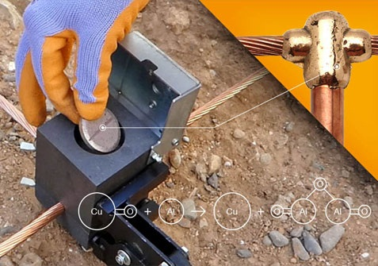
Exploring the Benefits and Applications of Exothermic Welding Powder in Electrical Systems
In the realm of electrical safety and reliability, one of the key considerations is the integrity of connections within the earthing system. Traditional methods of joining conductors may pose challenges such as corrosion, poor conductivity, and high resistance, leading to potential hazards like overheating and electrical faults. However, there exists a solution that addresses these concerns effectively: exothermic welding powder. In this comprehensive guide, we’ll delve into the world of exothermic welding, its benefits, applications, and how it enhances electrical safety.
Understanding Exothermic Welding
Exothermic welding, also known as exothermic bonding or thermite welding, is a process used to create permanent, high conductivity connections between metal conductors. This method involves a chemical reaction between metal oxide and a reducing agent, typically aluminum and copper oxide, inside a graphite mold. The resulting exothermic reaction generates intense heat, melting the metals and forming a robust, molecular bond.
Benefits of Exothermic Welding
- High Conductivity: Exothermic welds offer extremely low resistance, ensuring efficient flow of electrical currents and minimizing voltage drops across connections.
- Longevity: Unlike mechanical connections or soldering, exothermic welds are highly durable and resistant to corrosion, ensuring longevity and reliability in various environments.
- Uniformity: The welding process creates uniform connections with consistent quality, eliminating the risk of loose connections or hot spots that can compromise electrical systems.
- Versatility: Exothermic welding can be used for various applications, including earthing systems, electrical grounding, railway bonding, and telecommunications infrastructure.
Applications of Exothermic Welding in Earthing Systems
One of the critical applications of exothermic welding is in the establishment of robust earthing systems. Proper earthing is essential for dissipating fault currents, ensuring equipment safety, and protecting personnel from electric shocks. Exothermic welding offers several advantages in this regard:
- Enhanced Safety: Exothermic welds provide secure connections that withstand environmental factors, preventing the loosening or degradation of connections over time.
- Low Resistance: The low resistance offered by exothermic welds ensures effective dissipation of fault currents, reducing the risk of equipment damage and electrical hazards.
- Reliability: By creating molecular bonds between conductors, exothermic welding eliminates the risk of high resistance or intermittent connections that can compromise the effectiveness of earthing systems.
- Cost-Effectiveness: While the initial investment in exothermic welding materials may be higher than traditional methods, the long-term reliability and reduced maintenance requirements offer cost savings over the lifespan of the earthing system.
Choosing the Right Exothermic Welding Supplier
Selecting a reputable exothermic welding supplier is crucial to ensuring the quality and reliability of the welding materials. When choosing a supplier, consider the following factors:
- Product Quality: Look for suppliers that offer high-quality exothermic welding powder, molds, and accessories, ensuring consistent performance and reliability.
- Technical Support: A reliable supplier should provide comprehensive technical support, including assistance with product selection, application guidelines, and troubleshooting.
- Certifications and Standards: Ensure that the supplier complies with relevant industry standards and certifications, demonstrating their commitment to quality and safety.
- Customer Reviews and Reputation: Research customer reviews and testimonials to gauge the supplier’s reputation for product quality, reliability, and customer service.
By partnering with a trusted exothermic welding supplier, you can ensure the successful implementation of exothermic welding solutions in your earthing systems, enhancing safety and reliability.
Conclusion
In conclusion, exothermic welding powder offers a versatile and reliable solution for establishing robust connections in earthing systems and various other electrical applications. Its ability to create permanent, low-resistance bonds makes it an ideal choice for ensuring the safety and efficiency of electrical installations. When considering exothermic welding solutions for your projects, it’s essential to partner with a reputable supplier like Genius Protection System, known for its commitment to quality, reliability, and customer satisfaction. With exothermic welding, you can enhance the integrity of your electrical systems and mitigate potential hazards, ensuring optimal performance and safety for years to come.

Source URL: - https://lightningprotectionsystem51.wordpress.com/2024/04/05/enhancing-electrical-safety-with-exothermic-welding-a-comprehensive-guide/

Address:
Corp Off: DCT - 601, DLF City Court, Sikanderpur, Gurgaon (H.R.)-122002
Factory: 47/13, Ganpati Dham Ind, Area Bahadurgarh (H.R)-124507
Email: - info@gpsindia.co.in
Call Us: - +91-9313916302
Facebook | Instagram

