Erectile Wellness Enriched With Almonds

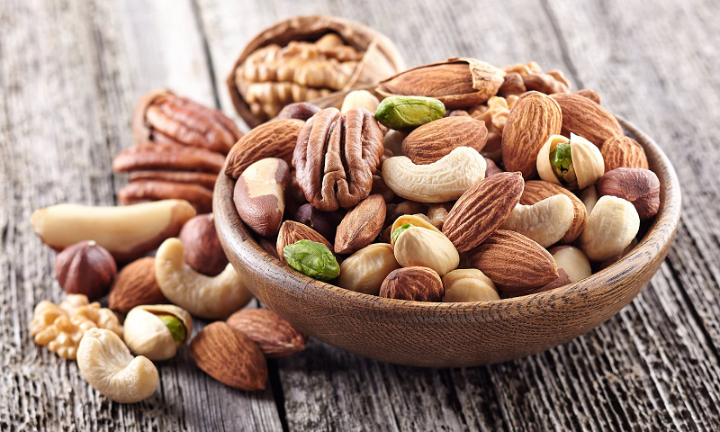
For most men suffering from erectile dysfunction, lifestyle changes can make all the difference. Eating a balanced diet, reducing stress through mindfulness practices and getting regular exercise are just a few things that can improve erections.
Adding almonds to these lifestyle changes can also help boost sexual function and performance. Learn more about the amazing benefits of these nuts!

1. Rich in Vitamin E
A tablespoon of almonds packs an impressive amount of vitamin E, a multi-tasking nutrient that protects against oxidative stress and is essential for normal DNA synthesis and the proper functioning of your immune system.
Almonds are also high in vitamin K, riboflavin, magnesium and protective phytosterol antioxidants. They contain more monounsaturated fat and less polyunsaturated fat than walnuts, making them a better option for those on low-carb diets.
Almonds also contain a type of vitamin E called gamma-tocopherol, which helps fight free radicals that are linked to cancer. Numerous studies find that people who eat nuts regularly have a reduced risk of developing cancer of the colon, prostate and breasts.

2. Improves Circulation
The antioxidants and healthy fats in almonds improve the health of blood vessels to allow smooth, unobstructed flow of blood throughout the body. It also contains nutrients that decrease inflammation and prevent blood clots from forming, lowering blood pressure.
In addition, the soluble fiber in almonds helps improve digestion and lower cholesterol. A study published in the journal Metabolism found that when a group replaced their usual snacks with 50g of almonds a day, it not only lowered LDL-cholesterol but improved other markers like apolipoprotein B and apo A-1 ratio.
Consuming a handful of almonds a day can help to reduce stress levels and boost memory. This is due to the presence of vitamin E, folate, fatty acids and magnesium, among others. Almonds are a good source of omega-3 fatty acids.

3. Lowers Cholesterol
Almonds are high in fat, but it's the healthy, unsaturated type that reduces low-density lipoprotein (LDL) cholesterol levels in the blood. Almonds can also help keep blood pressure in check. Kamagra Jelly Australia is a prescription medication that efficiently increases testosterone levels in males.
In addition to being a great source of fiber, almonds and almond skins contain prebiotic compounds that improve gut health by boosting the production of bifidobacteria and lactobacillus bacteria. These nutrients are needed for regulating digestion and the body's pH level.
In one small study, eating a handful of almonds four times a week lowered LDL cholesterol in participants. Almonds also boost the immune system. A serving of almonds -- about 23 nuts or 1/4 cup — contains vitamin E, which is essential for immune system support. In fact, researchers found that almonds can even increase white blood cell levels, helping the body ward off common cold and flu viruses.

4. Boosts Immune System
You can get plenty of immune-boosting vitamins and minerals from whole, soaked almonds. They're rich in Vitamin E, which is a multi-tasking nutrient that protects the cells from oxidative damage. Vidalista 20mg is a medication designed to address the challenges of ED.
Adding nuts to your diet helps nurture the billions of good bacteria living in your gut, a critical part of your immune system. One study found that people who ate almonds and almond skins for 6 weeks had significantly higher levels of the good bacteria Bifidobacteria and Lactobacillus than those who didn't.
Almonds are also packed with gut-healthy fiber and the plant compounds quercetin and kaempferol. These help lower inflammation in the digestive tract, reduce unwanted stress and promote healthy digestion.

5. Detoxifies the Body
The nutrient-rich almond is packed with nutrients that improve blood flow and enhance sexual function. According to a recent study, diets supplemented with almond drupe and seed were found to improve blood glucose levels, phosphodiesterase-5 activity, nitric oxide, H2S, and sexual hormones in diabetic rats. Visit AllDayawake for more information.
Almonds are also a great source of L-arginine and vitamin E, which have been shown to improve sexual function in men by boosting testosterone levels, as well as magnesium and zinc, both of which help relax blood vessels and improve libido and pleasure. However, almonds should not be relied upon as the sole treatment for erectile dysfunction or low libido; it is important to consult with a healthcare professional to address any underlying medical issues.

