Budget-Friendly Home Improvement Hacks

Introduction
Welcome to our blog, where we believe that home improvement doesn't have to break the bank! Are you looking for some budget-friendly hacks to spruce up your living space? Well, you've come to the right place. In this article, we will share some clever and creative ideas on how to transform every room in your house without draining your wallet. Whether it's a kitchen update or a bathroom makeover, we've got you covered with these affordable and easy-to-implement home improvement hacks.

Hacks for Every Room in the House
When it comes to home improvement, we often think of big renovations and hefty price tags. But what if I told you that there are simple hacks that can transform every room in your house without breaking the bank? Yes, you heard me right! These budget-friendly hacks will give your home a fresh new look without draining your wallet.
Let's start in the heart of the home – the kitchen. One easy hack is to update your cabinet hardware. Swapping out old knobs and pulls for sleek and modern ones can instantly elevate the look of your kitchen. Another tip is to add a backsplash. You don't need expensive tiles; adhesive wallpaper or vinyl decals can do wonders!
Now, let's move on to the bathroom. An inexpensive way to spruce up this space is by replacing outdated faucets and showerheads with more stylish options. Additionally, adding a fresh coat of paint or some peel-and-stick wallpaper can completely transform the walls.
Next up, let's head into the bedroom where comfort is key. A quick hack here is to invest in new bedding – soft sheets, fluffy pillows, and a cozy duvet will make all the difference in creating a relaxing oasis.
Let's not forget about the living room – where family gatherings happen and memories are made. One clever hack for this space is using multipurpose furniture pieces like storage ottomans or coffee tables with hidden compartments. This allows you to declutter while maximizing functionality.
In conclusion (remember not to use these words!), there are countless budget-friendly hacks for every room in your house that can give it a fresh new look without costing a fortune. So go ahead and get creative – transforming your home has never been easier!

Kitchen Hacks
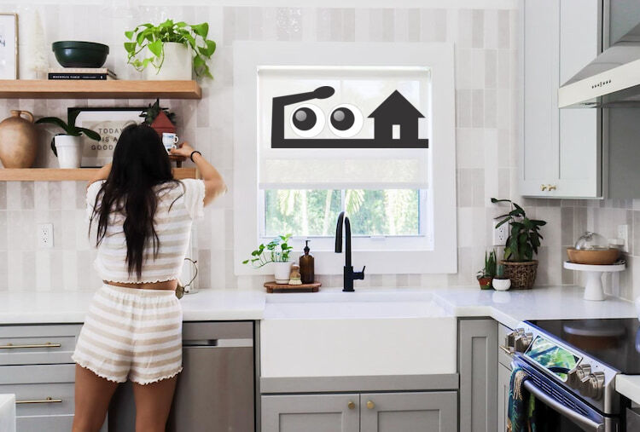

The kitchen is the heart of every home, but it can also be a place where chaos and clutter take over. Luckily, there are some easy and budget-friendly hacks that can help you keep your kitchen organized and efficient.
Maximize your cabinet space by installing hooks on the inside of cabinet doors. This simple trick allows you to hang measuring cups, pot holders, or even small utensils, saving valuable drawer space.
Another great hack is to use tension rods under your sink. By placing them horizontally across the inside walls of the cabinet, you can create additional storage for cleaning supplies or spray bottles.
If you're tired of searching through tangled cords in your kitchen drawers, try this neat hack: use empty toilet paper rolls as cord organizers. Simply fold up the cords and slip them into the rolls for a tangle-free solution.
To make meal prep easier and more efficient, invest in a magnetic knife strip. Not only will it free up counter space previously occupied by a bulky knife block, but it also keeps your knives easily accessible while cooking.
Don't overlook the power of labels! Use adhesive labels or chalkboard paint to label jars and containers in your pantry. This not only adds an element of organization but makes finding ingredients quick and easy.
By implementing these simple kitchen hacks into your daily routine, you'll be amazed at how much time and frustration they save you in the long run!

Bathroom Hacks
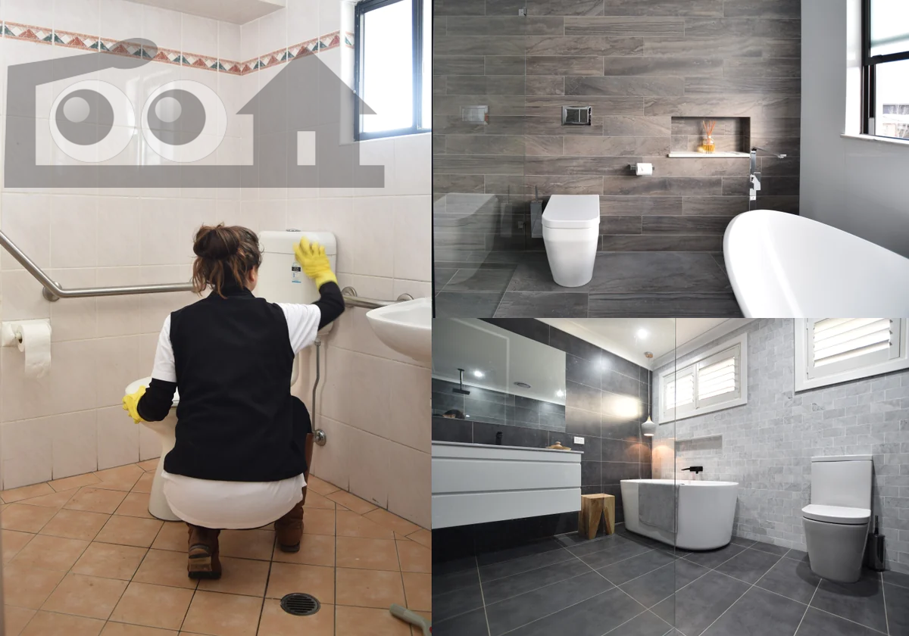
1. Organize with baskets: Keep your bathroom essentials tidy by using baskets to store towels, toiletries, and cleaning supplies. This not only adds a touch of organization but also makes it easier to find what you need.
2. DIY air fresheners: Instead of spending money on expensive air fresheners, make your own using simple ingredients like baking soda and essential oils. Mix them together and place in small sachets or jars to keep your bathroom smelling fresh.
3. Repurpose old items: Give new life to old items by repurposing them for bathroom use. For example, an old ladder can be transformed into a towel rack or a mason jar can be used as a toothbrush holder.
4. Maximize storage space: Utilize every inch of available space in your bathroom by installing shelves above the toilet or adding hooks on the back of the door for hanging robes or towels.
5. Clean showerhead with vinegar: Is your showerhead clogged? Fill a plastic bag with vinegar, tie it around the showerhead overnight, and watch as the mineral deposits dissolve away.
6. Use tension rods creatively: Tension rods are versatile tools that can be used in various ways in the bathroom. Install one under your sink to hang spray bottles or use them inside cabinets to create extra shelving.
7. Upgrade lighting fixtures: Change outdated light fixtures with modern ones for an instant upgrade that will brighten up your entire bathroom.
Remember, these hacks are budget-friendly alternatives that will transform any dull bathroom into a functional and stylish space!

Bedroom Hacks

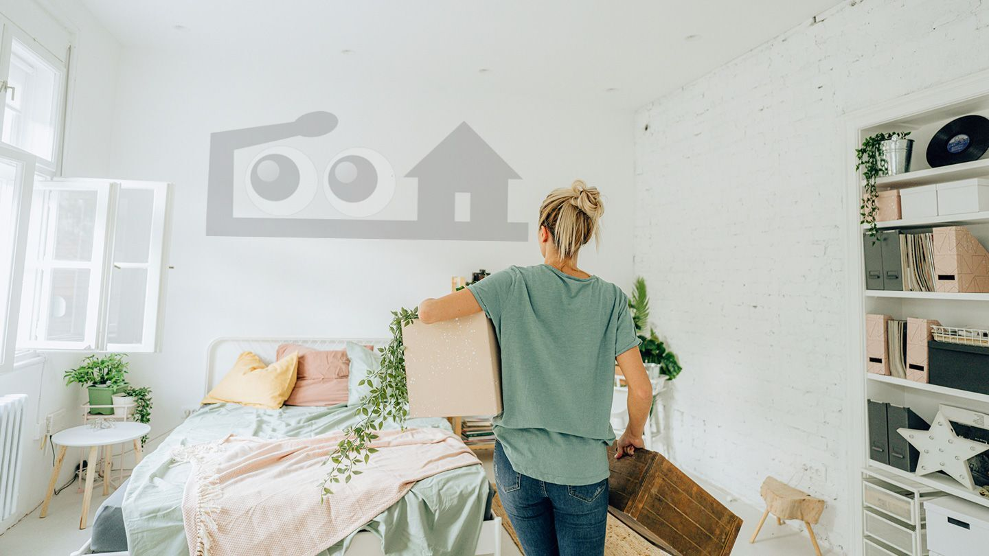
Your bedroom is your sanctuary, a place where you can unwind and recharge. But sometimes, it may feel cluttered or lacking in style. Don't worry! Here are some budget-friendly hacks to transform your bedroom into a cozy haven.
First things first, DE cluttering is key. Start by getting rid of unnecessary items and organizing your belongings. Invest in storage solutions such as bed with storage boxes or hanging organizers to maximize space.
Next, let's talk about lighting. Soft, warm lighting can instantly create a relaxing ambiance in your bedroom. Consider adding string lights or fairy lights around the bedframe or draping them across the walls for an ethereal effect.
When it comes to bedding, opt for neutral colors and textures that evoke tranquility. Layer different pillows and throws for added comfort and style.
One clever hack is utilizing vertical space by installing floating shelves above your headboard or along empty walls. This not only provides extra storage but also adds visual interest to the room.
Don't underestimate the power of plants! Adding greenery can breathe life into any space while improving air quality. Choose low-maintenance plants like succulents or snake plants that thrive indoors with minimal care.
By incorporating these simple hacks into your bedroom decor, you'll create a serene retreat without breaking the bank!

Living Room Hacks
1. Maximize Storage: One of the biggest challenges in the living room is clutter. To tackle this, invest in multi-functional furniture pieces with hidden storage compartments. Ottomans or coffee tables with built-in storage can help keep blankets, magazines, and other items out of sight.
2. Rearrange Furniture: Sometimes a simple rearrangement can completely transform your living room's look and feel. Experiment with different layouts to create more space or highlight certain features like a fireplace or large window.
3. Lighting Tricks: Good lighting can instantly enhance the ambiance of your living room. Consider adding floor lamps or table lamps for softer lighting options, as well as dimmer switches to control brightness levels.
4. DIY Artwork: Don't break the bank on expensive artwork when you can create your own! Get creative by framing personal photos, painting abstract designs on canvases, or using wall decals to add personality to your walls without spending a fortune.
5. Accent Pillows and Throws: Easily update the color scheme and style of your living room by swapping out accent pillows and throws seasonally or whenever you need a change.
6. Create Zones: If you have an open-concept living area, define separate zones for different activities such as reading nooks or entertainment areas using rugs and furniture placement.
Remember that these hacks are just starting points – let your imagination guide you when it comes to personalizing your living space! With some creativity and resourcefulness, even small changes can make a big impact on improving your home without breaking the bank!

Conclusion
These budget-friendly home improvement hacks are a great way to spruce up your living space without breaking the bank. Whether you're looking to update your kitchen, bathroom, bedroom, or living room, there are plenty of simple and affordable solutions that can make a big impact.
Remember, home improvement doesn't always have to be expensive or time-consuming. By implementing these hacks and getting creative with what you already have, you can transform your home into a stylish and comfortable haven.
So why wait? Start tackling those home improvement projects today and enjoy the satisfaction of seeing your space transformed in no time. Happy hacking!

