The Growing Demand for Ready-Mix Concrete: Trends and Opportunities in the Market
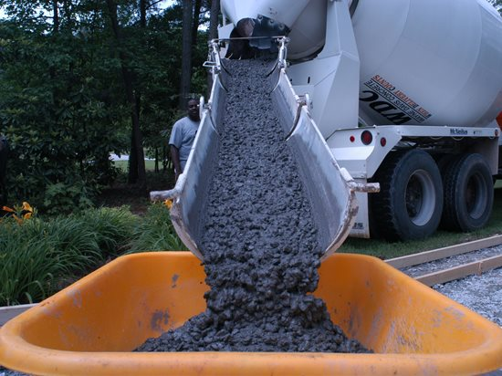
The global ready-mix concrete market has been experiencing significant growth in recent years, driven by the increasing demand for construction and infrastructure projects worldwide. Ready-mix concrete is a versatile and widely used building material that offers several advantages over traditional concrete, including consistency, quality, and convenience. This article explores the growing demand for ready-mix concrete, highlighting the key trends and opportunities in the market.
The global ready-mix concrete market is projected to grow from $792.2 billion in 2021 to $1,374.2 billion in 2028 at a CAGR of 8.2% in the forecast period.
Trends in the Ready-Mix Concrete Market:
The ready-mix concrete market has witnessed several trends in recent years. One of the most significant trends is the shift towards sustainable and eco-friendly concrete. With the growing awareness of environmental concerns, manufacturers are focusing on developing concrete that uses recycled materials and has a lower carbon footprint.
Another important trend is the increasing use of automation and technology in the production and delivery of ready-mix concrete. This has led to improved efficiency, accuracy, and safety, while also reducing the environmental impact of transportation.
Challenges in the Ready-Mix Concrete Market:
Despite the growth and potential of the ready-mix concrete market, there are several challenges that need to be addressed. One of the biggest challenges is the high cost of production and transportation, which can limit the availability of ready-mix concrete in certain regions.
Another challenge is the lack of standardization and quality control in some markets, which can lead to variations in the quality and performance of ready-mix concrete.
Opportunities in the Ready-Mix Concrete Market:
The ready-mix concrete market presents several opportunities for growth and innovation. One of the key opportunities is the development of new and advanced concrete mixtures that offer enhanced performance and durability. This has led to collaborations between manufacturers, researchers, and construction companies, resulting in the development of new concrete mixtures with unique properties.
Infrastructure Development:
Another major growth factor driving the ready-mix concrete market is infrastructure development. Governments around the world are investing heavily in infrastructure development projects such as roads, bridges, airports, and buildings. Ready-mix concrete is a preferred material for infrastructure development projects due to its high-quality, consistency, and durability. The growing investment in infrastructure development is driving the demand for ready-mix concrete.

Growing Emphasis on Sustainable Construction Practices:
The growing emphasis on sustainable construction practices is also driving the growth of the ready-mix concrete market. Ready-mix concrete is a sustainable material that offers several environmental benefits, such as reducing the carbon footprint of construction projects. The increasing adoption of sustainable construction practices is driving the demand for ready-mix concrete.
Opportunities and Challenges:
The ready-mix concrete market presents several opportunities for growth and innovation. One of the key opportunities is the development of new and advanced types of ready-mix concrete that offer better performance and sustainability. This presents an opportunity for manufacturers to differentiate themselves in a highly competitive market.
However, the growth of the ready-mix concrete market also presents several challenges. One of the key challenges is the availability of raw materials, particularly in emerging economies. The availability of raw materials such as aggregates, cement, and water can impact the production and supply of ready-mix concrete.
Conclusion:
The ready-mix concrete market is expected to continue its growth trajectory in the coming years, driven by the increasing demand for high-quality construction materials, infrastructure development, and the growing emphasis on sustainable construction practices. While the market presents several opportunities for growth and innovation, it also presents several challenges that need to be addressed. As the industry continues to evolve, we can expect to see new technologies and materials that will shape the future of the ready-mix concrete market.

