Revolutionizing Earthing Systems:
The Power of Exothermic Welding Services in India
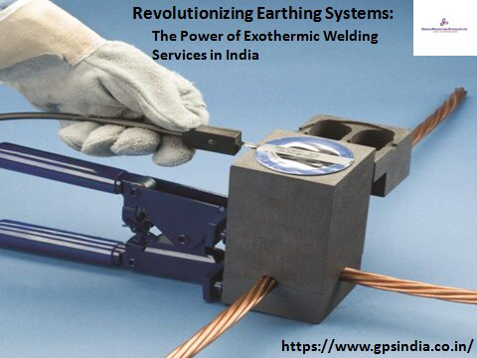
Enhancing Safety and Efficiency with Exothermic Welding in Earthing Systems
In today’s rapidly evolving technological landscape, ensuring the safety and efficiency of electrical systems is vital. As industries and infrastructures continue to expand, the demand for reliable earthing systems has grown exponentially. Exothermic welding emerges as a radical solution, offering unparalleled reliability and durability in grounding applications. This article explores the significance of exothermic welding services in India, flaking light on its transformative impact on earthing systems.
Understanding Exothermic Welding: A Game-Changer in Earthing Systems
Exothermic welding, also known as exothermic bonding or thermite welding, is an established method for creating permanent, high-quality electrical connections. Unlike traditional methods such as firmness or mechanical connectors, exothermic welding utilizes a chemical reaction to generate intense heat, fusing metals together at a molecular level. This process results in a robust, low-resistance bond that withstands corrosion, moisture, and environmental stresses, making it ideal for earthing applications.
The Advantages of Exothermic Welding in Earthing Systems
Exceptional Durability: Exothermic welds exhibit unmatched strength, ensuring long-term performance even in harsh conditions. By creating a molecular bond between metals, exothermic welding eliminates the risk of loosening or rust common with traditional connectors.
Low Resistance: Maintaining low resistance is critical in earthing systems to facilitate efficient dissipation of fault currents. Exothermic welds offer significantly lower resistance compared to mechanical connections, minimizing voltage drops and enhancing system performance.
Enhanced Safety: Reliable earthing is essential for protecting personnel and equipment from electrical hazards. Exothermic welding provides a secure connection that reduces the risk of ground faults, ensuring a safe working environment.
Ease of Installation: Exothermic welding offers simplicity and efficiency in installation, eliminating the need for specialized tools or equipment. With the right training, technicians can perform exothermic welds quickly and accurately, minimizing downtime and labor costs.
Exothermic Weld Powder Manufacturer: Driving Innovation in Electrical Connectivity
As the demand for exothermic welding services grows, the role of manufacturers becomes increasingly significant. Exothermic weld powder manufacturer play a crucial role in supplying high-quality materials essential for successful welds. These manufacturers stick to severe quality standards to ensure the reliability and performance of their products, supporting the flawless integration of exothermic welding in earthing systems.
Exothermic Welding Manufacturer in India: Meeting the Nation’s Infrastructure Needs
In India, the adoption of exothermic welding has gained momentum, driven by the country’s ambitious infrastructure development initiatives. With a growing emphasis on safety and efficiency, industries across sectors are turning to exothermic welding solutions for their earthing requirements. Recognizing this demand, several Indian manufacturers have emerged as leaders in the exothermic welding market, offering cutting-edge products and services adapted to local needs.
Genius Protection System: Pioneering Excellence in Exothermic Welding Services
Among the prominent players in the Indian exothermic welding industry, Genius Protection System stands out for its commitment to excellence and innovation. As a trusted provider of exothermic welding services in India, Genius Protection System combines technical expertise with advanced materials to deliver superior solutions to its clients. From consultation and design to installation and maintenance, Genius Protection System offers comprehensive support throughout the project lifecycle, ensuring optimal performance and reliability of earthing systems.
Conclusion: Partnering for a Safer, More Reliable Future
In conclusion, the adoption of exothermic welding in earthing system represents a significant advancement in electrical connectivity technology. With its exceptional durability, low resistance, and enhanced safety features, exothermic welding offers a transformative solution for industries seeking reliable grounding solutions. As India continues to invest in infrastructure development, the demand for exothermic welding services is expected to rise further. Companies like Genius Protection System are at the forefront of this revolution, driving innovation and excellence in electrical connectivity to create a safer and more reliable future.

Source URL: https://lightningprotectionsystem51.wordpress.com/2024/04/17/revolutionizing-earthing-systems-the-power-of-exothermic-welding-services-in-india/

Address:
Corp Off: DCT - 601, DLF City Court, Sikanderpur, Gurgaon (H.R.)-122002
Factory: 47/13, Ganpati Dham Ind, Area Bahadurgarh (H.R)-124507
Visit Here: - https://www.gpsindia.co.in/
Email: - info@gpsindia.co.in
Call Us: - +91-9313916302
Facebook | Instagram

