Revolutionizing Electrical Connections: The Power of Exothermic Welding
In the realm of electrical engineering, precision and reliability are paramount. This is where exothermic welding emerges as a game-changer, offering unparalleled strength and durability in electrical connections. As we delve into the world of exothermic welding, we'll explore its components, benefits, and the top manufacturers in India.
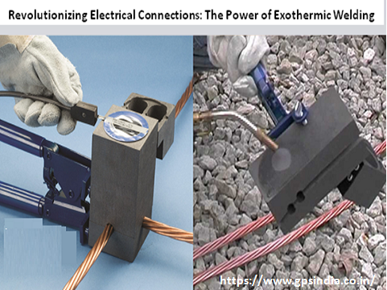
Understanding Exothermic Welding and Its Components
At the heart of exothermic welding lies the cadweld exothermic weld powder. This specialized powder is a blend of finely powdered metals and chemical compounds designed to produce a high-temperature reaction when ignited. When combined with a CADWELD mold, a conductive connection of superior quality is formed.
Exothermic welding manufacturers in India play a crucial role in providing high-quality CADWELD exothermic weld powder and molds to meet the diverse needs of the electrical industry. These manufacturers utilize advanced techniques and stringent quality control measures to ensure the reliability and performance of their products.
The Advantages of Exothermic Welding in Electrical Systems
Durability: Exothermic welds create robust connections that withstand corrosion, moisture, and other environmental factors, ensuring long-term reliability in electrical systems.
Low Resistance: Unlike traditional mechanical connections, exothermic welds offer low resistance, minimizing energy loss and ensuring efficient electrical conductivity.
Versatility: Exothermic welding is suitable for various applications, including earthing systems, rail connections, and cable joints, making it a versatile solution for diverse electrical infrastructure needs.
Ease of Installation: With the right equipment and training, exothermic welding is relatively straightforward to perform, reducing installation time and labor costs.
Consistency: Exothermic welding produces consistent results, eliminating the variability often associated with mechanical connections and ensuring uniform quality across installations.
Exothermic Welding Suppliers: Meeting the Industry's Needs
In India's burgeoning electrical industry, several exothermic welding suppliers stand out for their commitment to quality and innovation. These suppliers offer a comprehensive range of products, including CADWELD exothermic weld powder, molds, and accessories, catering to the diverse needs of electrical contractors, utilities, and industries.
Exothermic welding suppliers play a vital role in supporting the seamless integration of exothermic welding technology into various electrical projects, providing technical expertise, training, and ongoing support to ensure successful outcomes.
The Role of Genius Protection System in Advancing Exothermic Welding Technology
Among the leading exothermic welding manufacturers in India, Genius Protection System has established itself as a trusted name in the electrical industry. With a focus on innovation and customer satisfaction, Genius Protection System delivers cutting-edge solutions for electrical connections, including high-quality CADWELD exothermic weld powder and molds.
Genius Protection System's commitment to excellence extends beyond product quality, encompassing comprehensive technical support, training programs, and tailored solutions to meet the unique requirements of each project. By partnering with Genius Protection System, electrical contractors and industries can harness the full potential of exothermic welding technology, ensuring superior performance and reliability in their electrical installations.
In conclusion, exothermic welding represents a paradigm shift in electrical connections, offering unmatched durability, efficiency, and reliability. With top-tier manufacturers like Genius Protection System leading the way, the future of exothermic welding in India's electrical industry looks brighter than ever.

Source URL: - https://amrita420555.collectblogs.com/72054657/revolutionizing-electrical-connections-the-power-of-exothermic-welding

Address:
Corp Off: DCT - 601, DLF City Court, Sikanderpur, Gurgaon (H.R.)-122002
Factory: 47/13, Ganpati Dham Ind, Area Bahadurgarh (H.R)-124507
Email: - info@gpsindia.co.in
Call Us: - +91-9313916302
Facebook | Instagram

