Enhancing Electrical Safety: The Role of Exothermic Welding in Earthing Systems
Introduction
In the realm of electrical safety, one crucial aspect that demands attention is the earthing system. An effective earthing system ensures the safe dissipation of electrical currents, protecting both people and equipment from potential hazards. In this article, we will delve into the significance of exothermic welding in earthing system, shedding light on the key role it plays in bolstering electrical safety.
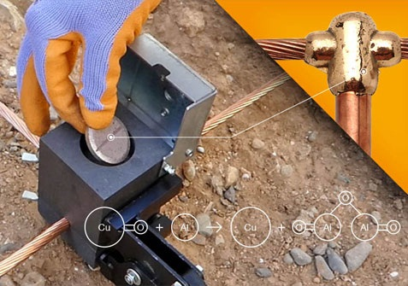
Understanding Exothermic Welding in Earthing Systems
Exothermic welding, also known as exothermic bonding, is a process widely employed in the installation and maintenance of earthing systems. Unlike traditional methods that involve mechanical connections, exothermic welding creates a permanent, molecular bond between conductors. This welding technique offers several advantages, including low resistance, durability, and resistance to corrosion.
Key Benefits of Exothermic Welding in Earthing Systems
- Low Resistance and Enhanced Conductivity
Exothermic welding ensures a low-resistance connection, facilitating the efficient dissipation of fault currents into the ground. This characteristic is crucial for maintaining the integrity of the earthing system, preventing potential damage to electrical equipment and ensuring the safety of personnel.
2. Durability in Harsh Environments
One of the standout features of exothermic welding is its durability, even in harsh environmental conditions. The welded connections are resistant to corrosion, ensuring a long lifespan for the earthing system. This durability is especially critical in industrial settings, where exposure to various elements can compromise the effectiveness of traditional earthing methods.
3. Consistent Performance over Time
Exothermic welding creates a reliable and consistent connection that withstands the test of time. This stability is vital for the continuous and uninterrupted functioning of the earthing system, reducing the need for frequent maintenance and ensuring a reliable electrical infrastructure.
Exothermic Welding Manufacturers in India: A Closer Look
Growing Demand for Exothermic Welding Solutions
As industries and infrastructure projects in India continue to expand, there is a growing demand for reliable and efficient earthing systems. Recognizing this need, several manufacturers in India have emerged as leaders in the production of exothermic welding materials and equipment.
- Innovation in Welding Materials
Leading exothermic welding manufacturers in India, such as Genius Protection System, are at the forefront of innovation in welding materials. These companies offer a range of high-quality exothermic welding kits, molds, and accessories designed to meet the diverse needs of electrical installations across industries.
2. Adherence to International Standards
Companies like Genius Protection System prioritize quality and adhere to international standards in the manufacturing of exothermic welding products. This commitment ensures that the end-users receive products that meet stringent safety and performance requirements, instilling confidence in the reliability of the earthing systems.
The Future of Electrical Safety: Exothermic Welding as a Standard Practice
Advancements and Evolving Standards
As technology advances and electrical systems become more sophisticated, the standards for safety and performance evolve as well. Exothermic welding is positioned to become a standard practice in the installation and maintenance of earthing systems, providing a robust solution to meet the demands of modern electrical infrastructure.
Conclusion: Genius Protection System Leading the Way
In conclusion, the incorporation of exothermic welding in earthing systems is a pivotal step towards enhancing electrical safety. As industries in India embrace this advanced technique, companies like Genius Protection System play a crucial role in providing cutting-edge solutions. Their commitment to innovation, adherence to international standards, and dedication to electrical safety makes them a prominent player in the exothermic welding manufacturing landscape. With the relentless pursuit of excellence, Genius Protection System stands as a beacon, contributing to the evolution of electrical safety practices in India.

Source URL: - https://medium.com/@amrita420555/enhancing-electrical-safety-the-role-of-exothermic-welding-in-earthing-systems-84055d8bee3d

Address:
Corp Off: DCT - 601, DLF City Court, Sikanderpur, Gurgaon (H.R.)-122002
Factory: 47/13, Ganpati Dham Ind, Area Bahadurgarh (H.R)-124507
Email: - info@gpsindia.co.in
Call Us: - +91-9313916302
Facebook | Instagram

