Unveiling the Best Chemical Earthing Electrode Manufacturers in India:
A Comprehensive Guide by Genius Protection Systems
Discovering Top-tier Chemical Earthing Electrode Manufacturers near You for Optimal Grounding Solutions
In the realm of electrical engineering, grounding systems are indispensable for ensuring safety, operational efficiency, and equipment protection. Among various grounding solutions, chemical earthing electrodes have emerged as a reliable choice for industries, commercial establishments, and residential complexes alike. However, finding the best chemical earthing electrode manufacturers in India can be a daunting task amidst a sea of options. Fear not, for in this comprehensive guide, we navigate through the maze of offerings to unveil the top contenders, including Genius Protection Systems, who are revolutionizing the landscape of grounding solutions.
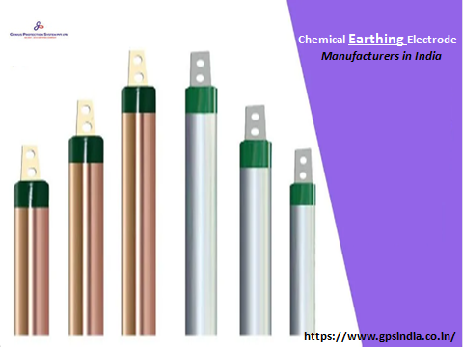
The Importance of Grounding Systems:
Before delving into the realm of chemical earthing electrode manufacturers, it’s crucial to understand the significance of grounding systems in electrical installations. Grounding serves as a pathway for fault currents to safely dissipate into the earth, preventing electric shocks, fires, and equipment damage. Moreover, proper grounding mitigates electromagnetic interference and ensures firm operation of receptive electronic devices.
Exploring the Best Chemical Earthing Electrode Manufacturers:
· Genius Protection Systems: Renowned for their commitment to quality and innovation, Genius Protection Systems stands tall as one of the premier chemical earthing electrode manufacturers in India. With state-of-the-art facilities and a team of experienced engineers, they offer a diverse range of grounding solutions tailored to meet the unique needs of clients across various industries.
· Leaders in Innovation: Genius Protection Systems leverages cutting-edge technologies and stringent quality control measures to deliver superior products that surpass industry standards. Their chemical earthing electrodes are engineered for durability, corrosion resistance, and high conductivity, ensuring long-term reliability and performance.
· Customer-Centric Approach: What sets Genius Protection Systems apart is their unwavering dedication to customer satisfaction. From project inception to execution, their team provides comprehensive support and guidance, ensuring seamless integration of grounding solutions into diverse applications.
Choosing the Right Manufacturer:
When selecting a chemical earthing electrode manufacturer, several factors come into play. Quality, reliability, technical expertise, and after-sales support are top considerations that can control the effectiveness and longevity of grounding systems. By partnering with reputable manufacturers like Genius Protection Systems, customers can rest assured knowing they’re investing in top-tier solutions backed by industry-leading expertise and support.
Conclusion:
In the realm of electrical engineering, the importance of grounding systems cannot be overstated. As discerning consumers seek out the best chemical earthing electrode manufacturers in India, companies like Genius Protection Systems emerge as beacons of excellence, offering unparalleled quality, innovation, and customer-centric solutions. With a steadfast commitment to excellence, Genius Protection Systems continues to redefine the standards of grounding technology, ensuring safety, reliability, and peace of mind for clients across the globe. When it comes to grounding solutions, trust the experts at Genius Protection Systems to deliver nothing short of perfection.

Source URL: https://medium.com/@amrita420555/unveiling-the-best-chemical-earthing-electrode-manufacturers-in-india-a-comprehensive-guide-by-c34053785536
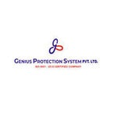

Address:
Corp Off: DCT - 601, DLF City Court, Sikanderpur, Gurgaon (H.R.)-122002
Factory: 47/13, Ganpati Dham Ind, Area Bahadurgarh (H.R)-124507
Visit Here: - https://www.gpsindia.co.in/
Email: - info@gpsindia.co.in
Call Us: - +91-9313916302
Facebook | Instagram

